CHAPTER 9
ROTATION OF RIGID BODIES
Discussion Questions

Q9.1 Yes for (a), (b), (d) and (e). In each case the equation is true for any instant of time. Changes of quantities over time don’t enter into the equation, so it doesn’t matter how and are changing. No for (c). If changes with t then the equation doesn’t even have precise meaning. What value of would be used, the value at 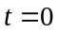or the value at the final t or something else?

Q9.2 (a) The mass of the molecule has the same distribution about the x-axis as it does about the z-axis. Therefore, the moment of inertia of the molecule for the x-axis as the axis of rotation is the same as for the z-axis. The kinetic energy will be K. (b) If the atoms are treated as point masses, the mass lies on the y-axis and the moment of inertia for the y-axis as the rotation axis is zero and the kinetic energy will be zero.

Q9.3 The tangential acceleration is tangential to the circular path of the point. The tangential acceleration is equal to the rate of change of the linear speed of the point. The radial acceleration is radially inward, toward the center of the circular path of the point. The radial acceleration expresses the rate of change of the direction of the velocity of the point.

Q9.4 Yes, is the rate of change of the speed so it is the same for all points on the chain. 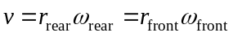 so 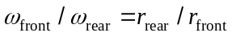. The angular acceleration is the rate of change of the angular speed so 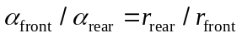. and are larger for the smaller sprocket.

Q9.5 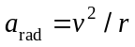 and is the same at the rim of each sprocket, so 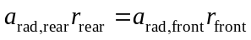 and 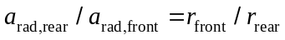; 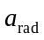 is larger at the rim of the smaller sprocket.

Q9.6 The tangential acceleration is the rate of change of the angular speed so for constant angular velocity the tangential acceleration is zero. The radial acceleration is 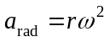 so if is constant, is constant. The direction of is always toward the center of the flywheel, but this direction changes in space as the flywheel rotates.

Q9.7 The spin cycle removes water from the clothes. The clothes turn at the rim of the drum with a large angular speed so they have a large inward radial acceleration . The force on the water isn’t large enough to provide this acceleration to the water and the water doesn’t stay in the circular path of the clothes. It leaves tangentially through holes in the drum.

Q9.8 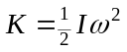. Since all the objects have the same , the object with the largest has the largest 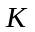 and the object with the smallest has the smallest . The moment of inertia for each object is:
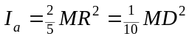
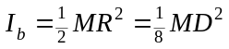
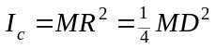
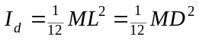
Since all the objects have the same 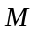, the smallest is 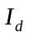 and the largest is 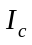. Object c has the greatest kinetic energy and object d has the least.

Q9.9 It is not possible for a body to have the same moment of inertia for all possible axes. The mass of the body cannot be distributed the same relative to all axes, including those that lie outside the body. Yes, a sphere has the same moment of inertia for all axes passing through its center.

Q9.10 To maximize the moment of inertia the mass should be as far from the rotation axis as possible. This is achieved when all the mass is at the rim, when the flywheel has the shape of a thin-walled hollow cylinder or hoop.
Q9.11 Mount the object on a horizontal axle of radius that lies along the axis. Let the axle turn in frictionless bearings. Wrap a light cord around the axle and suspend a mass from the free end of the cord, as in Fig.9.17. Release the system from rest and measure the linear speed of the mass after it has descended a vertical distance . Conservation of energy gives 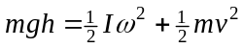. Use 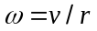 and solve for .

Q9.12 No. The farthest each piece of mass can be from the axis is and the largest possible moment of inertia about the symmetry axis is 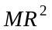.

Q9.13 The thin plate can be constructed from thin rods laid side to side, parallel to side . Each rod, of mass 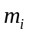, has 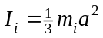. The total is the sum of the contribution from each rod and is 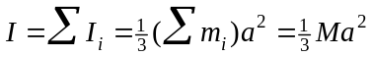, where is the sum of the masses of the rods and therefore is the mass of the plate.

Q9.14 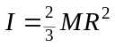. 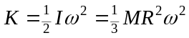. Let 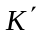 be the new kinetic energy, 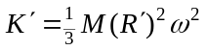. 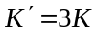 so 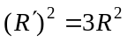 and 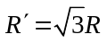.

Q9.15 The cross section of the rod need not be circular for these equations to apply. For the equations to apply, all points on a thin-slice must be to a good approximation the same distance from the axis. For this to be so, the lateral dimensions of the rod must be much less than its length.

Q9.16 The discussion in Q9.15 applies to part (d). For part (c) the thickness of the plate has no effect on how the mass is distributed relative to the axis so the thickness of the plate doesn’t matter.

Q9.17 Ball A will have more kinetic energy. Conservation of energy applied to the system of the ball and the pulley gives 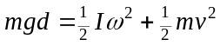, where d is the distance the ball has fallen and m is the mass of the ball. 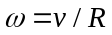. Pulley B has a greater moment of inertia for rotation about an axis at its center. Therefore, for a given d, more of the total kinetic energy of the system will reside with the pulley in case B and therefore the kinetic energy of the ball will be less.

Q9.18 Greater than V. Moving the balls closer to the drum decreases the moment of inertia of the pulley about its rotation axis. 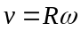, where R is the radius of the drum and is constant. Conservation of energy gives 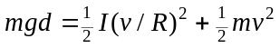. Smaller I means that the pulley has a smaller fraction of the total kinetic energy of the system and for a given d the kinetic energy of the box therefore is greater.

Q9.19 In the constant angular acceleration equations (9.7), (9.10), (9.11) and (9.12) you can use any angular measure. The same number of angular quantities appear in each term of the equations so converting from one angular measure to another would just multiply the whole equation by an overall factor, and this doesn’t change the equation. 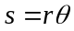 requires that be in radians; this equation in fact defines the radian. Equations (9.13) through (9.15) and Eq.(9.17) are all derived using so they also require the use of radian measure.

Q9.20 No. A simple counter-example is the solid sphere. The moment of inertia through the center of the sphere is 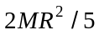. The center of mass is at the center of the sphere so calculating by placing all the mass at the center of mass gives the incorrect value of zero.

Q9.21 (a) All points have the same angular speed; it is the same atand B. (b) so the tangential speed is greater at point . (c) The angular acceleration is the time rate of change of the angular velocity, so is the same at and . (d) 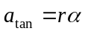 so is larger at . (e) so is larger at .
Q9.22 A simple model for my body is a vertical cylinder with mass M and radius R and two slender rods for my outstretched arms. I estimate the radius of this cylinder to be about 0.15 m. My height is about 1.7 m so the volume of the cylinder is 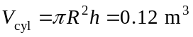. For each outstretched arm, the distance from the tip of my fingers to the center of my chest is about 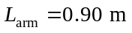and the average radius for each arm, modeled as a cylinder, is about 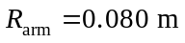. So, the volume of each arm, in this simple model, is 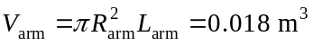. My total volume then is about 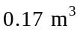 and about 11% of my volume is in each arm and therefore 78% is in the rest of my body. My total mass is 82 kg. If the average density of my arms is assumed to be the same as for the rest of my body, then the mass of each of my arms is 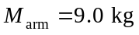 and the mass of the rest of my body is 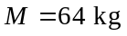. Therefore, my moment of inertia about the specified axis is 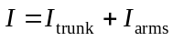. . .
My total moment of inertia is therefore approximated to be 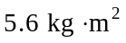. My outstretched arms have a much greater I than the rest of my body, even though they have only about 20% of my mass because for them their mass is distributed farther from the axis.

